#FFFFFF



#000000



#3F3D56



(side bar)

#4E5151B8



#0000005E



#645E5E29



#107DAC



(Header/ Major Color)

#41B3FE



#09D8F95E



#F18E1E



#F9BA66

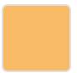

#DFFF00

